**KATHFORD INTERNATIONAL COLLEGE OF ENGINEERING AND MANAGEMENT**

**Balkumari, Lalitpur**

**Affiliated to Tribhuvan University**

**Institute of Science and Technology**

**A Project Report on**

**AAMDAANI**

**Submitted to**

**Department of Computer Science and Information Technology**

**Kathford International College of Engineering and Management**

***In Partial Fulfillment for the second semester course Fundamentals of Computer Programming (CSC-102) of Bachelor of Science in Computer Science and Information Technology (B.Sc.CSIT)***

**Under Supervision of**

Ms. Deni Shahi

(Lecturer, B.Sc.CSIT, Kathford College)

**Submitted By:**

Kushal Kc (17)

Mala Thapa Magar (19)

Namkong Hang Kirat (23)

Neha Adhikari (24)

November 2016

**Kathford International College of Engineering and Management Balkumari, Lalitpur**

**LETTER OF APPROVAL**

This is to certify that this project prepared by Kushal Kc, Mala Thapa Magar, Namkong Hang Kirat, Neha Adhikari entitled “**AAMDAANI**” in partial fulfillment of the requirements for the second semester course **Data Structure and Algorithm (CSC-154)** of B.Sc. in Computer Science and Information Technology has been well studied. In our opinion it is satisfactory in the scope and quality as a project for the required subject.

………….………………. ………….……………….

Project Supervisor HoD of Computer Science and Technology

Kathford International College of Kathford International College of

Engineering and Management Engineering and Management

………………………….. …………………………..

SIGNATURE SIGNATURE

External Examiner Internal Examiner

**Kathford International College of Engineering and Management**

**Balkumari, Lalitpur**

**Supervisor’s Recommendation**

I hereby recommend that this project prepared under my supervision by Kushal Kc, Mala Thapa Magar, Namkong Hang Kirat, Neha Adhikari entitled “**AAMDAANI**” in partial fulfillment of the requirements for the second semester course **Data Structure and Algorithm(CSC-154)** of B.Sc. in Computer Science and Information Technology be processed for evaluation.

………………………...

Project Supervisor

Kathford International College of

Engineering and Management.

**ABSTRACT**

“AAMDAANI” is a simple monetary management system for just about anyone. It can be used by a housewife, a student or just a normal person to record their daily monetary transactions. It provides capabilities for entering the monetary transactions whether earned or spent, helps divide the expenditures in different categories, aggregate the monthly income and expenditures, evaluate the total saving or loss at the end of the month. This will help an individual to manage his income accordingly.

Different monetary management system has been made digital through several programming appeals today in order to make the system easy, efficient and comprehensible.

So we have thought of designing this project, **AAMDAANI** is based on C language and concept of data structures and algorithm. With knowledge of unambiguous syntax commonly used in C will make this project completely understandable and easy to implement.

**ACKNOWLEDGMENT**

We are very much thankful to the Department of Computer Science and Information Technology, Kathford Int’l College of Engineering and Management for accepting our report proposal on “AAMDAANI” and granting us the opportunity of work undertaken. We express our earnest gratitude for providing us with all essential cooperation, valuable suggestion and the necessary resources during all the quarters of the completion of the report.

For the accomplishment of this report, a number of people have become a part of it. Firstly, we are deeply indebted to our Supervisor and HoD of CSIT for their kind support, coordination and valuable supervision from starting to end of this report without which this report could not come in this form.

We are also thankful to our friends who have contributed directly or indirectly in the accomplishment of our report.

We would also like to acknowledge and extend our gratitude to everyone for his/her support and encouragement.

**CONTENTS**

**Contents Page Number**

INTRODUCTION 1 OBJECTIVES AND METHODOLOGY 2 SCOPE AND LIMITATIONS 3 IMPLEMENTATION

1. Algorithm 4-18
2. Flowchart 19-20
3. Header Files 21
4. Structure 21
5. User-defined functions 22

CONCLUSION AND ENHANCEMENTS 23

APPENDICES 24-29

SOURCE CODE 30-98

REFERENCES AND BIBLIOGRAPHY

**INTRODUCTION**

**AAMDAANI**

This is a simple monetary management system for just about anyone. It can be used by a shopkeeper, a housewife, a student or just a normal person to record their daily monetary transactions. It provides capabilities for entering the monetary transactions whether earned or spent, helps divide the expenditures in different categories, aggregate the monthly income and expenditures, evaluate the total saving or loss at the end of the month. This will help an individual to manage his income accordingly.

The aim of this project is to implement a monetary management system which is easy to use and is suitable for every person having daily monetary transactions.

**PROBLEM STATEMENT**

Managing monetary transaction is difficult using traditional methods. Using a manual system is challenging as the records can be scattered, can be redundant and may be very time consuming. All these problems are solved using this project. Throughout the project the focus has been on keeping records in an easy and intelligible manner.

“Aamdaani” is an automated version of manual monetary transactions records and using this software means eliminating the tedious physical transaction records on paper and making it digital and easier. The vision is to provide a progressive and expandable monetary management to every people using the program. Only authorized users ae allowed to enter through the system. So security is also maintained in the system. Overall, it will make recording financial transactions an easier task for the user.

1

**OBJECTIVES AND METHODOLOGY**

**OBJECTIVE**

General:

* The main purpose of this project is to help any user to maintain their monetary transaction data and help them find total expenses or savings at the end of the month.
* It will facilitate keeping all the records of expense based on the category like Food, Clothes, and Household etc.
* So, all the information about the daily monetary transactions will be managed and can be easily available when needed.

Specific:

* To allow the user to enter and save the personal monetary transactions and to also allow the user to edit those records.
* Finding total income and expenditure.
* Determining total savings or loss.
* Deleting the pre-recorded information.

**METHODOLOGY**

We used

* Reference book
* Web surfing

2

**SCOPE AND LIMITATIONS**

**SCOPE**

This system makes easy to track expenses, manage budgets and save money. It is easy and efficient personal finance manager and expense tracker. It provides capabilities for entering the monetary transactions whether earned or spent, helps divide the expenditures in different categories, aggregate the monthly income and expenditures, evaluate the total saving or loss at the end of the month. This will help an individual to manage his income accordingly. Further in this project we can add other features as well. Pie charts can be included so that there would be clear vision of our expenses in our income.

**LIMITATION**

We have done our best to make our project eligible for every kind of purpose but also there are some limitations that we were unable to handle. Some of the limitations are listed below:

* Transactions are executed in off-line mode.
* Off-line information cannot be generated.
* The existing system only provides text-based interface, which is not as user-friendly as Graphical user Interface.
* At first the user have to enter user and user as username and password and then only user can personalize the system.

3

**IMPLEMENTATION**

**Algorithm**

**Main function:**

Step 1: Start

Step 2: call welcome()

Step 3: Input character c

Step 4: If c==’L’ or c==’l’

Call user()

Step 5: If (c==27) goto step 7

Step 6: Goto step 3

Step 7: End

**User()**

Step 1: Start

Step 2: Print “Only 3 attempts will be allowed to enter username and password

Step 3: Input username and password as user.name and user.password

Step 4: If cnt==2

Print “You have entered wrong username and/or password three times”

Print “Press enter to exit the program”

Goto step 10

4

Step 5: Read name and password from file “USER.DAT” as nam and pass.

Step 6: If user.name and nam and user.password and pass matches

c=1

Step 7: cnt=cnt + 1

Step 8: If c==1

Call main_menu()

Else

Print “Invalid username and/or password!”

Print “Press enter to try again”

Step 9: Goto step 4

Step 10: End

**Main_menu()**

Step 1: Start

Step 2: Print

1. Record Income
2. Record Expenditure
3. Display transaction
4. Edit transaction
5. Delete transactions
6. Change username/password
7. Exit

Step 3: Print “Press a choice between the ranges (1-5)”

5

Step 4: Switch (getch()-48)

Case 1: call rec_inc()

Case 2: call rec_exp()

Case 3: call display()

Case 4: call tran_delete()

Case 5: call tran_edit()

Case 6: Print “Are you sure you want to exit? <Y/N>”

If ex==’Y’ or ex==’y’

Goto step 5

Else call main_menu()

Default:

Print "Your input is out of range! Enter a choice from 1 to 6!”

Print “Press any key to continue”

Step 5: End

6

**Rec_inc()**

Step 1: Start

Step 2: Print

1. Interest money
2. Award
3. Salary
4. Gift
5. Selling
6. Others
7. Back to main menu

Step 3: Print “Press a choice between the ranges (1-7)”

Step 4: Switch(getch()-48)

Case 1: type=1;tran_main_inc(type)

Case 2: type=2;tran_main_inc(type)

Case 3:type=3;tran_main_inc(type)

Case 4:type=4;tran_main_inc(type)

Case 5:type=5;tran_main_inc(type)

Case 6:type=6;tran_main_inc(type);

Case 7: call main_menu()

Default: Print “Your input is out of range! Enter a choice between 1 to 7!”

Print “Press any key to continue”

Call rec_inc()

7

**Tran_main_inc()**

Step 1: Start

Step 2: Open file “INCOME.DAT” for read mode

Step 3: if inputc<=trans.c

inputc++

Step 4: trans.c=inputc

Step 5: switch (type)

Case 1: Copy "Interest Money" to trans.t_type

Case 2: Copy "Award" to trans.t_type

Case 3: Copy “Salary” to trans.t_type

Case 4: Copy "Gifts” to trans.t_type

Case 5: Copy "Selling" to trans.t_type

Case 6: Copy “Others" to trans.t_type

Step 6: Print "Choose transaction occurrence date:"

Print

1. Today
2. Input Date by self

Step 7: "Press a choice between 1 and 2”

8

Step 8: switch(date)

Case 1: Input Income amount in NRs as trans.amt

Print "Are you sure you want to record this transaction? <Y/N>"

if ch=='Y' or ch=='y'

Open file “INCOME.DAT” in append mode to record transaction

Print “Transaction recorded successfully!”

Case 2: Input Date in the format mm/dd/yy

Input Income Amount (in NRs.)

Print "Are you sure you want to record this tranasction? <Y/N>"

If ch=='Y or|ch=='y'

Open file “INCOME.DAT” in append mode to record transaction

Print “Transaction recorded successfully!”

Default: Print “Your input is out of range!”

Print “Press any key to continue”

Call tran_main_inc(type)

9

**Rec_exp()**

Step 1: Start

Step 2: Print

1. Food & Beverage
2. Bills & Utilities
3. Shopping
4. Transportation
5. Friends & Family
6. Entertainment
7. Health & Fitness
8. Gift & Donation
9. Others
10. Back to Main Menu

Step 3: Print “Enter a choice between the ranges [1-10]”

Step 4: Switch(sw)

Case 1: type=1; call tran_main_exp(type)

Case 2: type=2; call tran_main_exp(type)

Case 3: type=3; call tran_main_exp(type)

Case 4: type=4; call tran_main_exp(type)

Case 5: type=5; call tran_main_exp(type)

Case 6: type=6; callmtran_main_exp(type)

Case 7: type=7; call tran_main_exp(type)

Case 8: type=8; call tran_main_exp(type)

10

Case 9:type=9;tran_main_exp(type);

Case 10: call main_menu

Default: Print “Your input is out of range! Enter a choice from 1 to 10!”

Print “Press any key to continue”

**tran_main_exp()**

Step 1: Start

Step 2: Open “EXPENSE.DAT” file in read mode

Step 3: if (outputc<=trans.c)

outputc++

Step 4: trans.c=output

Step 5: switch (type)

Case 1: Copy "Food & Beverage" to trans.t_type

Case 2: Copy "Bills & Utilities” to trans.t_type

Case 3: Copy "Shopping" to trans.t_type

Case 4: Copy "Transportation" to trans.t_type

Case 5: Copy "Friends & Family" to trans.t_type

Case 6: Copy "Entertainment" to trans.t_type

Case 7: Copy "Health & Fitness” to trans.t_type

Case 8: Copy "Gift & Donation" to trans.t_type

11

Case 9: Copy “Others" to trans.t_type

Step 6: Print “Choose transaction occurrence date”

Print “1.Today 2. Input Date by self”

Step 7: Print “Press a choice between 1 and 2”

Step 8: switch (getch()-48)

Case 1: Input Expense Amount (in NRs.) as trans.amt

Print "Are you sure you want to record this transaction? <Y/N>"

if ch=='Y' or ch=='y'

Open file “EXPENSE.DAT” in append mode to record transaction

Print “Transaction recorded successfully!”

Case 2: Input Date in the format mm/dd/yy

Input Income Amount (in NRs.)

Print "Are you sure you want to record this tranasction? <Y/N>"

If ch=='Y or|ch=='y'

Open file “EXPENSE.DAT” in append mode to record transaction

Print “Transaction recorded successfully!”

Default: Print “Your input is out of range!”

Print “Press any key to continue”

Call tran_main_exp(type)

12

**Display()**

Step 1: Start

Step 2: Print

1. Income
2. Expense
3. Overall
4. Back to Main Menu

Step 3: Print “Press a choice between the ranges [1-4]”

Step 4: Switch(getch()-48)

Case 1: type=1; call disp_main(type)

Case 2: type=2; call disp_main(type)

Case 3: type=3; call disp_main(type)

Case 4: display()

Default: Print “Your input is out of range! Enter a choice from 1 to 4!”

Print “Press any key to continue"

**disp_main()**

Step 1: Start

Step 2: switch(type)

Case 1: Print every category of income and total income

Print “Press Backspace to go Back”

13

Case 2: Print every category of expense and total expense

Print “Press Backspace to go Back”

Case 3: Print every categories of income and expense. Print total inflow and total outflow

Print “Press Backspace to go Back”

**Tran_edit()**

Step 1: Start

Step 2: Print

1. Edit Income Transaction
2. Edit Expense Transaction
3. Back to Main Menu

Step 3: Print “Press a choice between the ranges [1-3]”

Step 4: switch(getch()-48)

Case 1: Enter transaction no. to edit

Open “INCOME_T.DAT” in read mode and “TEMP.DAT” in write mode

Print

1. Edit Transaction Type
2. Edit Date
3. Back Amount

Print “Press a choice between the range [1-3]”

14

switch(getch()-48)

Case 1: Edit income categories

Print” Transaction has been successfully edited!”

Case 2: Edit date

Print” Transaction has been successfully edited!”

Case 3: Edit amount

Print” Transaction has been successfully edited!”

Remove "INCOME_T.DAT" and rename "TEMP.DAT" as "INCOME_T.DAT"

Case 2: Enter transaction no. to edit

Open “EXPENSE_T.DAT” in read mode and “TEMP.DAT” in write mode

Print

1. Edit Transaction Type
2. Edit Date
3. Back Amount

Print “Press a choice between the ranges [1-3]”

switch(getch()-48)

Case 1: Edit expense categories

Print “Transaction has been sucessfully Edited!”

Case 2: Edit date

Print” Transaction has been successfully edited!”

15

Case 3: Edit amount

Print” Transaction has been successfully edited!”

Remove "INCOME_T.DAT" and rename "TEMP.DAT" as "INCOME_T.DAT"

Case 3: call tran_edit()

Default: Print “Your input is out of range! Enter a choice from 1 to 3!”

Print “Press any key to continue”

**Tran_delete()**

Step 1: Start

Step 2: Print

1. Delete Income Transaction
2. Delete Expense Transaction
3. Back to Main Menu

Step 3: Print “Press a choice between the ranges [1-3]”

Step 4: switch(getch()-48)

Case 1: Open “INCOME_T.DAT” in read mode

Print “Enter transaction no. to delete or press any other key to go back”

Open “TEMP.DAT” in write mode

If transaction no. matches

Print “Transaction has been successfully deleted!"

Write on “TEMP.DAT”

16

Remove “INCOME_T.DAT” and rename “TEMP.DAT” by “INCOME_T.DAT”

Case 2: Open "EXPENSE_T.DAT" in read mode

Print “Enter transaction no. to delete or press any other key to go back”

Open “TEMP.DAT” in write mode

If transaction no. matches

Print “Transaction has been successfully deleted!"

Write on “TEMP.DAT”

Remove "EXPENSE_T.DAT" and rename “TEMP.DAT” by "EXPENSE_T.DAT"

Case 3: Print “Your input is out of range! Enter a choice from 1 to 3!”

Print “Press any key to continue”

Call tran_delete()

**edit()**

Step 1: Start

Step 2: Input username and password as user.name and user.password

Step 3: Open file “ USER.DAT” in read mode

Step 4: Compare username and password

Step 5: If it does not match

Print “Wrong Username and/or Password”

17

Else

Print “Are you sure you want to CHANGE user name and/or password? <Y/N>”

Step 6: If ch=='Y' or ch=='y'

Input new username and password

Step 7: Remove "USER.DAT" and rename “TEMP.DAT" as “USER.DAT”

Step 8: Print “Record has been EDITED successfully!"

18

**Flowchart**

Start

Print “Press L to Log in or Esc to Exit”

c=='L' || c=='l'

User()

C==Esc

Yes

End

Yes

Input username and password

Wrong username or password?

Yes

No

Main_menu()

A

19

7

A

Print

1. Record cord Expenditure
2. Display transaction
3. Edit transaction
4. Delete transactions
5. Change username/password
6. Exit

Print “Press a choice from the range [1-7]”

Switch(choice)

Call rec_inc()

Call rec_exp()

Call display()

Call tran_edit()

Call tran_delete()

Call edit()

1

2

3

4

5

6

default

End

20

**Header files**

The header files used in the program are:

#include <stdio.h>

#include <stdlib.h>

#include <windows.h>

#include <conio.h>

#include <time.h>

#include <ctype.h>

#include <math.h>

**Structure**

Two structures are used in the program:

* struct trans

{

char t_type[25],_date[15],_ttime[10];

float amt;

int c;

};

* struct user

{ char name[30], password[30];

};

21

**User-defined functions**

* void gotoxy(int x,int y) : To move the cursor to x column and y row of output screen
* void _password(char buffer[]) : To input password from user so that asterik (*) is displayed for each character entered. Similar to gets(string); function
* void rectangle(int x,int y,int l,int b) : To make a rectangle starting from (x,y) with length l and breadth b
* void currency(char cur[], float n) : To convert a floating number n into currency format in Hindu Arabic Number system. Eg. On execution of the statement currency(cur,123456.789); the value of cur will be "1,23,456.78"
* void date_output(char date[]) : To convert date in format mm/dd/yy to dd MMM, yyyy. Eg. 01/01/11 is changed to 01 Jan, 2011
* void welcome() : Displays welcome screen that you see as soon as program is executed
* void title() : Clears the screen and displays program title and Current date on top of Screen
* void user() : Window to login to enter main menu of the program
* void main_menu() : Main menu of the program
* void rec_inc() : To record transaction regardina income
* void rec_exp() : To record transaction regarding expenditure
* void display() : To display overall transaction
* void edit(): To edit username and password
* void tran_delete() : To delete transaction
* void tran_edit() : To edit transaction
* void disp_main(int) : Main function to display transaction
* void tran_main_inc(int) : Main function to record income transaction
* void tran_main_exp(int) : Main function to record expense transaction

22

**CONCLUSION AND ENHANCEMENTS**

**Conclusion**

From this project we are able to program in a detailed way by evaluating our skills and this has boost up our confidence for future projects. This report is not quite so successful but it will surely make the user to use this system which is quite user friendly

* Helpful to perform paperless work and manage all data.
* Provides easy, accurate, unambiguous and faster data access.

**Enhancement**

AAMDAANI can be further enhanced to add other functionality also. Some of them are listed below:

* Make updates in design and features
* Provision of service to mobile phones with other mobile OS.
* Online accessible
* Linking with bank accounts

23

**APPENDICES**

**Snapshots**

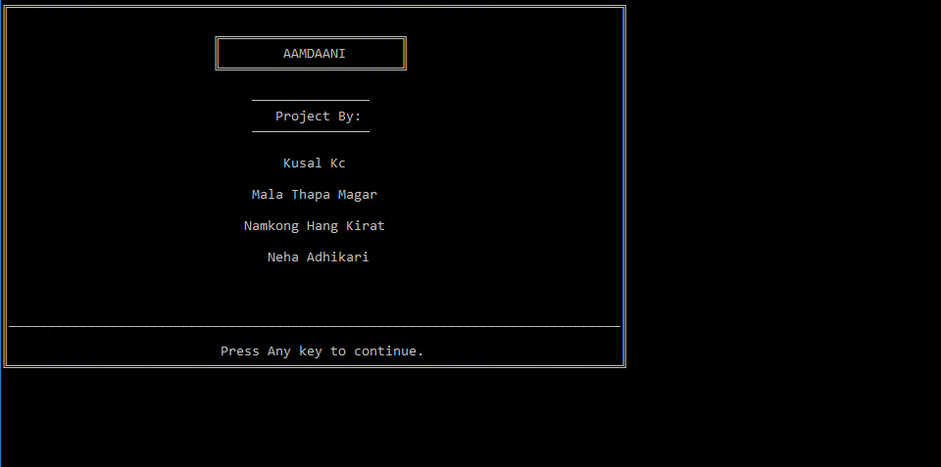

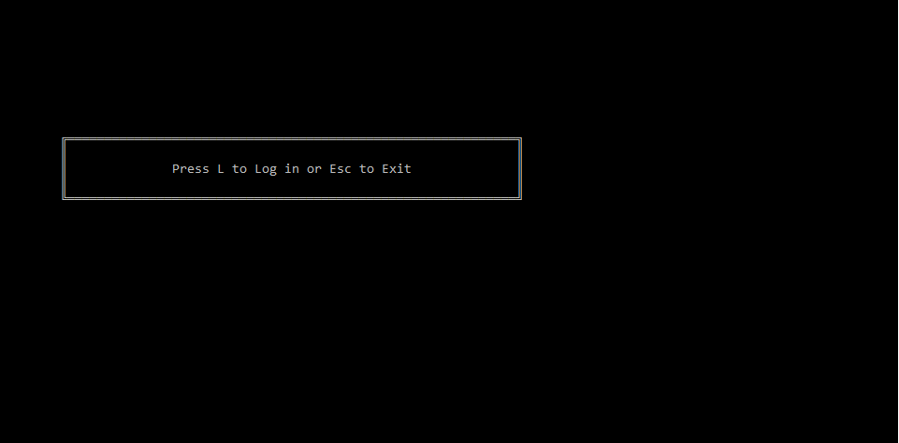

24

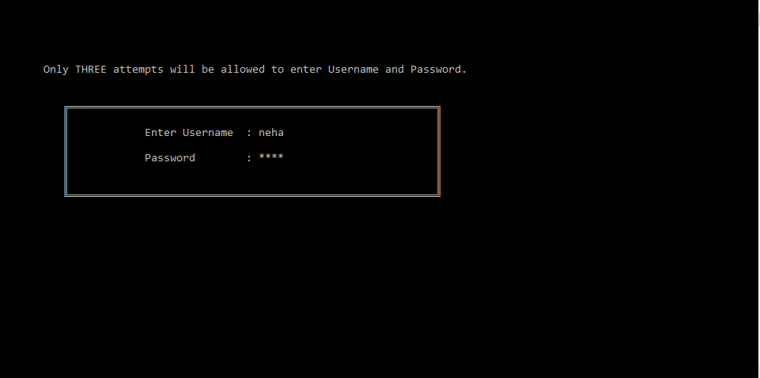

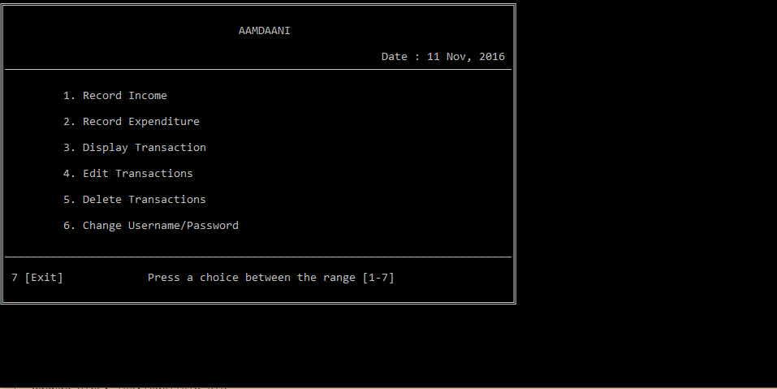

25

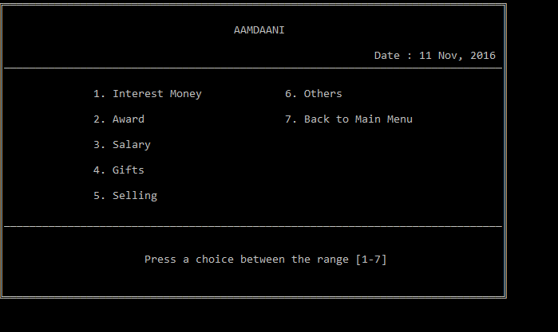

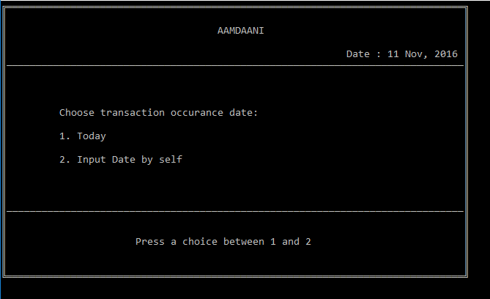

26

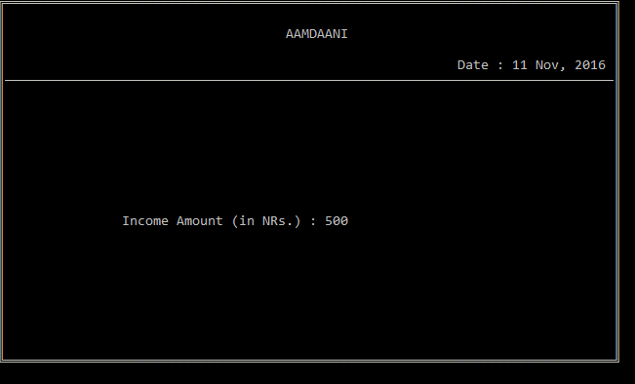

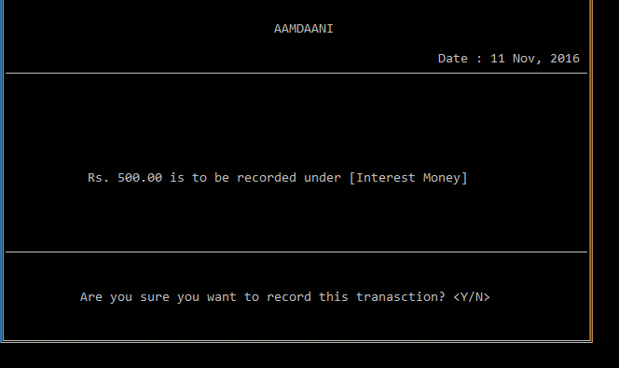

27

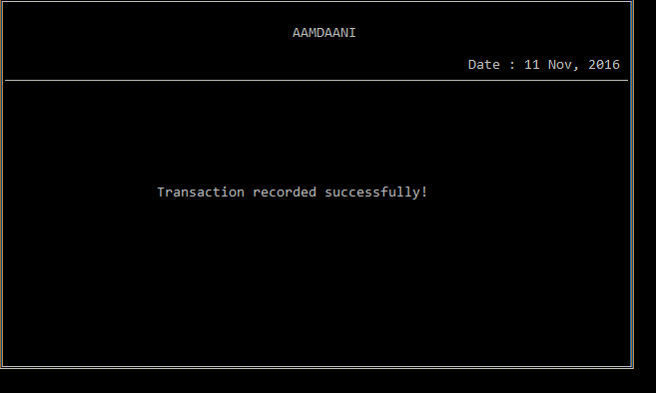

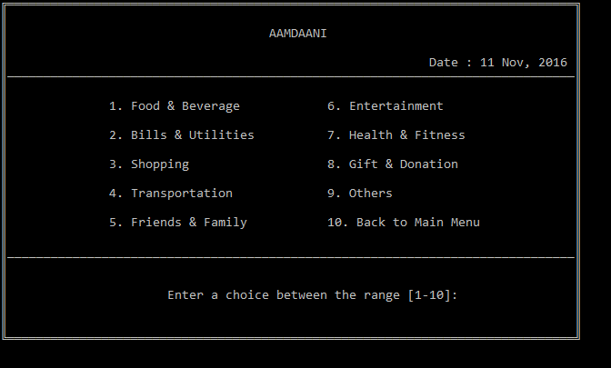

28

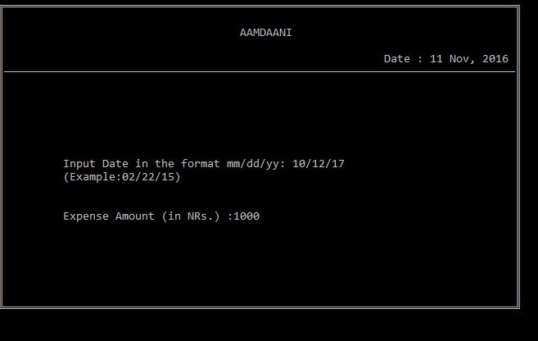

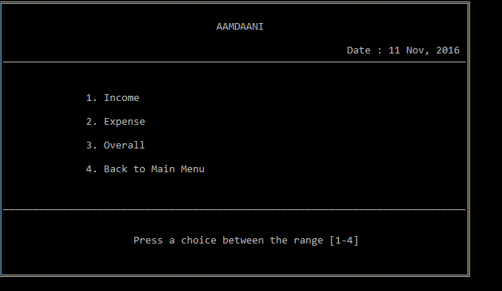

29

**Source code**

//Student Management System

//Submitted By: Kushal Kc

// Mala Thapa Magar

// Namkong Hang Kirat

// Neha Adhikari/*

//===========================================================//

#include <stdio.h>//For standard I/O Operation

#include <stdlib.h>//To use functions like system(); system("dos command"); - this performs the dos command given. Eg. system("cls"); - This command clears the screen

#include <windows.h>//Used in making gotoxy(int, int) function

#include <conio.h>//For getch(); getche() type of functions

#include <time.h>//To get system date and time

#include <ctype.h> //For isprint() type of functions.

#include <math.h>//To calculate mathematical problems, used esp. in interest calculation

struct trans//Structure for storing transaction information

{

char t_type[25],_date[15],_ttime[10];

float amt;

30

int c;

};

struct user//Structure for storing User information

{

char name[30], password[30];

};

FILE *fp,*tfp,*fp1;

char date[13],ttime[10];

int inputc=1,outputc=1; //Miscellaneous Functions

void gotoxy(int x,int y); //To move the cursor to x column and y row of output screen

void _password(char buffer[]);// To input password from user so that asterik (*) is displayed for each character entered. Similar to gets(string); function

void rectangle(int x,int y,int l,int b);// To make a rectangle starting from (x,y) with length l and breadth b

void currency(char cur[], float n); // To convert a floating number n into currency format in Hindu Arabic Number system. Eg. on execution of the statement currency(cur,123456.789); the value of cur will be "1,23,456.78"

void date_output(char date[]); //To convert date in format mm/dd/yy to dd MMM, yyyy. Eg. 01/01/11 is changed to 01 Jan, 2011

31

void welcome();// Displays welcome screen that you see as soon as program is executed

void title(); //Clears the screen and displays program title and Current date on top of Screen

//Main Functions

void user();//Window to login to enter main menu of the program

void main_menu(); //Main menu of the program

void rec_inc(); //To record transaction regardina income

void rec_exp(); //TO recored transaction regarding expenditure

void display(); //TO display overall transaction

void tran_delete(); //To delete transaction

void tran_edit(); //To edit transaction

void edit(); //To edit username and password

//Sub Functions

void disp_main(int); //Main function to display transaction

void tran_main_inc(int); //Main function to record income transaction

void tran_main_exp(int); //Main function to record expense transaction

int main()

{

char c;

32

welcome(); //Welcome sreen at beginning

do

{

system("cls"); //Clears the screen

rectangle(8,9,70,13);

gotoxy(23,11); printf("Press L to Log in or Esc to Exit");

c=getche(); //Variable c stores the key pressed by user

if (c=='L'||c=='l')

{

user();

break;

}

if (c==27) exit(0); //27 is ASCII code of escape key, means program exits when user presses Esc key insted to A or S

}while(1); //infinite loop incase any key other than Esc or L is pressed

return 0;

}

void user()

33

{

int i,ch; //Log in Screen begins...

char pass[30],nam[30];

int cnt,c;

struct user user;

cnt=0;//This variable cnt counts the number of attempts of Log in

do

{

system("cls");

rectangle(10,8,70,15);

gotoxy(7,5);printf("Only THREE attempts will be allowed to enter Username and Password.");

gotoxy(23,10); printf("Enter Username : "); gets(user.name);

gotoxy(23,12); printf("Password : ");

_password(user.password);

if (cnt==2)// when no of attempts exceeds 3 (0, 1 & 2)

{

title();

gotoxy(15,10); printf("You have entered wrong username and/or password three times.\n");

34

gotoxy(24,12);printf("Press ENTER to exit the program.");

getch();

exit(0);

}

fp=fopen("USER.DAT","r");

while(fscanf(fp,"%s %s\n",nam,pass)!=EOF)

{

if((strcmp(user.name,nam)==0)&&(strcmp(user.password,pass)==0))

{

c = 1;

}

}

cnt++; //if the combination doesn't match error text is shown and cnt is increased

fclose(fp);

title();

if(c==1)

{main_menu();} //main menu of the program is prompted

else

35

{

title();

gotoxy(25,10); printf("Invalid Username and/or Password!\a");

gotoxy(28,12);printf("Press ENTER to try again.");

getch();

}

} while(1);//not exactly infinite as user is prompted only maximum three times.

}

void main_menu()

{

int i;

char ex;

\system("cls");

do

{

title(); //Displays title and date at the top

gotoxy(10,7); printf("1. Record Income");

gotoxy(10,9); printf("2. Record Expenditure");

36

gotoxy(10,11); printf("3. Display Transaction");

gotoxy(10,13); printf("4. Edit Transactions");

gotoxy(10,15); printf("5. Delete Transactions");

gotoxy(10,17); printf("6. Change Username/Password");

gotoxy(2,21); printf("7 [Exit]");

gotoxy(1,19); for(i=0;i<78;i++) printf("_"); //prints long line of "_" to separate menu and choice input

gotoxy(23,21); printf("Press a choice between the range [1-7] ");

switch(getch()-48) //getch gets the int value of "charater" 1 to 5, to convert it to respective integer we subtract it by 48

{

case 1:rec_inc();

break;

case 2:rec_exp();

break;

case 3:display();

break;

case 4:tran_edit();

37

break;

case 5:tran_delete();

break;

case 6:edit();

break;

case 7:

{

title();

gotoxy(15,14); printf("Are you sure you want to exit? <Y/N> : ");

ex=getche();

if (ex=='Y'||ex=='y')

exit(0);

else

break;

}

default://when entered characted is not between 1-6

{

title();

gotoxy(12,12); printf("Your input is out of range! Enter a choice between 1 to 6!");

38

gotoxy(26,15); printf("Press any key to continue");

getch();

}

}

}while(1);//infinite loop to return to main menu after execution of any function

//return 0;

}

void rec_inc()

{

int i, type; //int type helps to determine the topic of transaction in the function tran_main_inc(type)

title();

gotoxy(15,7); printf("1. Interest Money\n");

gotoxy(15,9); printf("2. Award\n");

gotoxy(15,11); printf("3. Salary\n");

gotoxy(15,13); printf("4. Gifts\n");

gotoxy(15,15); printf("5. Selling\n");

gotoxy(45,7); printf("6. Others\n");

gotoxy(45,9); printf("7. Back to Main Menu\n");

gotoxy(1,17); for(i=0;i<78;i++) printf("_");

39

gotoxy(23,20); printf("Press a choice between the range [1-7] ");

switch(getch()-48)

{

case 1:type=1;tran_main_inc(type); //it calls function whic records income transaction

break;

case 2:type=2;tran_main_inc(type);

break;

case 3:type=3;tran_main_inc(type);

break;

case 4:type=4;tran_main_inc(type);

break;

case 5:type=5;tran_main_inc(type);

break;

case 6:type=6;tran_main_inc(type);

break;

case 7:

break;

default://when entered characted is not between 1-7

title();

40

gotoxy(12,12); printf("Your input is out of range! Enter a choice between 1 to 7!");

gotoxy(26,15); printf("Press any key to continue");

getch();

}

}

void rec_exp()

{

int i,sw,type; //int type helps to determine the topic of transaction in the function tran_main_exp(type)

title();

gotoxy(15,7); printf("1. Food & Beverage\n");

gotoxy(15,9); printf("2. Bills & Utilities\n");

gotoxy(15,11); printf("3. Shopping\n");

gotoxy(15,13); printf("4. Transportation\n");

gotoxy(15,15); printf("5. Friends & Family\n");

gotoxy(45,7); printf("6. Entertainment\n");

gotoxy(45,9); printf("7. Health & Fitness\n");

gotoxy(45,11); printf("8. Gift & Donation\n");

gotoxy(45,13); printf("9. Others\n");

gotoxy(45,15); printf("10. Back to Main Menu\n");

41

gotoxy(1,17); for(i=0;i<78;i++) printf("_");

gotoxy(23,20); printf("Enter a choice between the range [1-10]: ");

scanf("%d",&sw);

switch(sw)

{

case 1:type=1;tran_main_exp(type); //it calls a function which records expense transaction of type 1 ie.Food & Beverage

break;

case 2:type=2;tran_main_exp(type); //it calls a function which records expense transaction of type 2 ie.Bills & Utilities....etc

break;

case 3:type=3;tran_main_exp(type);

break;

case 4:type=4;tran_main_exp(type);

break;

case 5:type=5;tran_main_exp(type);

break;

case 6:type=6;tran_main_exp(type);

break;

case 7:type=7;tran_main_exp(type);

42

break;

case 8:type=8;tran_main_exp(type);

break;

case 9:type=9;tran_main_exp(type);

break;

case 10:

break;

default://when entered characted is not between 1-10

{title();

gotoxy(12,12); printf("Your input is out of range! Enter a choice between 1 to 10!");

gotoxy(26,15); printf("Press any key to continue");

getch();}

}

}

void display()

{

int i, type;

title();

gotoxy(15,8);printf("1. Income\n");

43

gotoxy(15,10);printf("2. Expense\n");

gotoxy(15,12);printf("3. Overall\n");

gotoxy(15,14);printf("4. Back to Main Menu\n");

gotoxy(1,17); for(i=0;i<78;i++) printf("_");

gotoxy(23,20);printf("Press a choice between the range [1-4] ");

switch(getch()-48)

{

case 1:type=1;disp_main(type); //it calls main display function which displays total incomes

break;

case 2:type=2;disp_main(type); //it calls main display function which displays total expenses

break;

case 3:type=3;disp_main(type); //it calls main display function which displays overall transactions

break;

case 4: break;

44

default://when entered characted is not between 1-8

{title();

gotoxy(12,12); printf("Your input is out of range! Enter a choice between 1 to 4!"); gotoxy(26,15); printf("Press any key to continue");

getch();}

}

}

void edit(){

Char nam[30], pass[30],ch, n_nam[30], n_pass[30]={0},passwrd[30]={0},n_pass1[30]={0};

struct user user;

int c=0,err=0;

title();

gotoxy(25,8);printf("User Name : ");

scanf("%s",user.name);

gotoxy(25,10);printf("Password : ");

_password(passwrd);

strcpy(user.password,passwrd);

fp=fopen("USER.DAT","r");

45

while(fscanf(fp,"

%s %s\n",nam,pass)!=EOF) //opeans USER.DAT and reads the content

{

if(strcmp(user.name,nam)==0&&strcmp(user.password,pass)==0) c++; //if input username and password matches c is increased

}

fclose(fp);

title();

if (c==0) //input username and password didn't match so c is not increased hence c=0

{

gotoxy(22,10); printf("Wrong Username and/or Password\a");

getch();

}

else

{

gotoxy(8,10); printf("Are you sure you want to CHANGE user name and/or password? <Y/N> : ");

46

ch=getche();

if(ch=='Y'||ch=='y')

{

do

{

title();

err=0;

gotoxy(25,8);

printf("NEW Username : ");

scanf("%s",n_nam);

gotoxy(25,10);

printf("NEW Password : ");

_password(n_pass);

gotoxy(25,12);

printf("Confirm NEW Password : ");

_password(n_pass1);

if (strcmp(n_pass,n_pass1)!=0) //comparing string of password and string of confirm password

{

47

title();

gotoxy(17,13);

printf("Password and confirm password does not match!\a");

getch();

err++;

}

} while(err!=0);

tfp=fopen("TEMP.DAT","a"); //opeans a temporary file

fprintf(tfp,"%s %s\n",n_nam,n_pass); //prints the new username pad password in it

fclose(tfp);

fclose(fp);

remove("USER.DAT"); //delete the old USER.DAT file

rename("TEMP.DAT","USER.DAT"); //rename the TEMP.DAT into USER.DAT

title();

gotoxy(21,13); printf("Record has been EDITED successfully!");

getch();

}

48

}

}

void tran_delete()

{

struct trans trans;

char ch,curr[35];

int c,i,j=1,k=0;

title();

gotoxy(15,10);printf("1. Delete Income Transaction\n");

gotoxy(15,12);printf("2. Delete Expense Transaction\n");

gotoxy(15,14);printf("3. Back to Main Menu\n");

gotoxy(1,17); for(i=0;i<78;i++) printf("_");

gotoxy(23,20);printf("Press a choice between the range [1-3] ");

switch(getch()-48)

{

case 1:

title();

gotoxy(2,6);puts("S.N.");

49

gotoxy(8,6);puts("Transaction Type");

gotoxy(36,6);puts("Date");

gotoxy(50,6);puts("Time");

gotoxy(61,6);puts("Amount (NRs.)");

gotoxy(1,7); for(i=1;i<79;i++) printf("%c",196);

fp=fopen("INCOME_T.DAT","r");

while(fread(&trans,sizeof(trans),1,fp)==1)

{

gotoxy(2,8+j);printf("%d.",trans.c);

gotoxy(8,8+j);printf("%s",trans.t_type);

strcpy(date,trans._date);

date_output(date);

gotoxy(36,8+j);printf("%s",date);

gotoxy(50,8+j);printf("%s",trans._ttime);

currency(curr,trans.amt);

gotoxy(61,8+j);printf("%s",curr);

j++;

}

50

fclose(fp);

gotoxy(1,20); for(i=0;i<78;i++) printf("_");

gotoxy(3,22);printf("Enter transaction no. to delete or press any other key to go back: ");

scanf("%d",&c);

fp=fopen("INCOME_T.DAT","r");

tfp=fopen("TEMP.DAT","w");

while(fread(&trans,sizeof(trans),1,fp)==1)

{

if(c==trans.c)

{title();

gotoxy(20,12);printf("Transaction has been sucessfully deleted!");

k=1;

getch();

}

else{

fwrite(&trans,sizeof(trans),1,tfp);

}

}

fclose(fp);

51

fclose(tfp);

remove("INCOME_T.DAT");

rename("TEMP.DAT","INCOME_T.DAT");

fp=fopen("INCOME_T.DAT","r");

tfp=fopen("TEMP.DAT","w");

while(fread(&trans,sizeof(trans),1,fp)==1)

{

if(trans.c<c)

{

fwrite(&trans,sizeof(trans),1,tfp);

}

else if(c<trans.c)

{

trans.c--;

fwrite(&trans,sizeof(trans),1,tfp);

}

}

fclose(fp);

52

fclose(tfp);

remove("INCOME_T.DAT");

rename("TEMP.DAT","INCOME_T.DAT");

break;

case 2:

title();

gotoxy(2,6);puts("S.N.");

gotoxy(8,6);puts("Transaction Type");

gotoxy(36,6);puts("Date");

gotoxy(50,6);puts("Time");

gotoxy(61,6);puts("Amount (NRs.)");

gotoxy(1,7); for(i=1;i<79;i++) printf("%c",196);

fp=fopen("EXPENSE_T.DAT","r");

while(fread(&trans,sizeof(trans),1,fp)==1)

{

gotoxy(2,8+j);printf("%d.",trans.c);

53

gotoxy(8,8+j);printf("%s",trans.t_type);

strcpy(date,trans._date);

date_output(date);

gotoxy(36,8+j);printf("%s",date);

gotoxy(50,8+j);printf("%s",trans._ttime);

currency(curr,trans.amt);

gotoxy(61,8+j);printf("%s",curr);

j++;

}

fclose(fp);

gotoxy(1,20); for(i=0;i<78;i++) printf("_");

gotoxy(3,22);printf("Enter transaction no. to delete or press any other key to go back: ");

scanf("%d",&c);

fp=fopen("EXPENSE_T.DAT","r");

tfp=fopen("TEMP.DAT","w");

while(fread(&trans,sizeof(trans),1,fp)==1)

{

if(c==trans.c)

{title();

54

gotoxy(20,12);printf("Transaction has been sucessfully deleted!");

k=1;

getch();

}

else{

fwrite(&trans,sizeof(trans),1,tfp);

}

}

fclose(fp);

fclose(tfp);

remove("EXPENSE_T.DAT");

rename("TEMP.DAT","EXPENSE_T.DAT");

fp=fopen("EXPENSE_T.DAT","r");

tfp=fopen("TEMP.DAT","w");

while(fread(&trans,sizeof(trans),1,fp)==1)

{

if(trans.c<c)

{

55

fwrite(&trans,sizeof(trans),1,tfp);

}

else if(c<trans.c)

{

trans.c--;

fwrite(&trans,sizeof(trans),1,tfp);

}

}

fclose(fp);

fclose(tfp);

remove("EXPENSE_T.DAT");

rename("TEMP.DAT","EXPENSE_T.DAT");

break;

case 3:

break;

default://when entered characted is not between 1-3

{title();

gotoxy(12,12); printf("Your input is out of range! Enter a choice between 1 to 3!");

gotoxy(26,15); printf("Press any key to continue");

56

getch();

tran_delete();}

}

}

void tran_edit()

{

struct trans trans;

char ch,curr[35];

int c,i,j=1,k=0;

title();

gotoxy(15,10);printf("1. Edit Income Transaction\n");

gotoxy(15,12);printf("2. Edit Expense Transaction\n");

gotoxy(15,14);printf("3. Back to Main Menu\n");

gotoxy(1,17); for(i=0;i<78;i++) printf("_");

gotoxy(23,20);printf("Press a choice between the range [1-3] ");

switch(getch()-48)

{

case 1:

57

title();

gotoxy(2,6);puts("S.N.");

gotoxy(8,6);puts("Transaction Type");

gotoxy(36,6);puts("Date");

gotoxy(50,6);puts("Time");

gotoxy(61,6);puts("Amount (NRs.)");

gotoxy(1,7); for(i=1;i<79;i++) printf("%c",196);

fp=fopen("INCOME_T.DAT","r");

while(fread(&trans,sizeof(trans),1,fp)==1)

{

gotoxy(2,8+j);printf("%d.",trans.c);

gotoxy(8,8+j);printf("%s",trans.t_type);

strcpy(date,trans._date);

date_output(date);

gotoxy(36,8+j);printf("%s",date);

gotoxy(50,8+j);printf("%s",trans._ttime);

currency(curr,trans.amt);

gotoxy(61,8+j);printf("%s",curr);

58

j++;

}

fclose(fp);

gotoxy(1,20); for(i=0;i<78;i++) printf("_");

gotoxy(3,22);printf("Enter transaction no. to edit or press any other key to go back: ");

scanf("%d",&c);

fp=fopen("INCOME_T.DAT","r");

tfp=fopen("TEMP.DAT","w");

while(fread(&trans,sizeof(trans),1,fp)==1)

{

if(c==trans.c)

{ title();

gotoxy(15,10);printf("1. Edit Transaction Type\n");

gotoxy(15,12);printf("2. Edit Date\n");

gotoxy(15,14);printf("3. Back Amount\n");

gotoxy(1,17); for(i=0;i<78;i++) printf("_");

gotoxy(23,20);printf("Press a choice between the range [1-3] ");

switch(getch()-48)

{

59

case 1:

title();

gotoxy(15,7); printf("1. Interest Money\n");

gotoxy(15,9); printf("2. Award\n");

gotoxy(15,11); printf("3. Salary\n");

gotoxy(15,13); printf("4. Gifts\n");

gotoxy(15,15); printf("5. Selling\n");

gotoxy(45,7); printf("6. Others\n");

gotoxy(1,17); for(i=0;i<78;i++) printf("_");

gotoxy(23,20); printf("Press a choice between the range [1-6] ");

switch(getch()-48)

{

case 1: strcpy(trans.t_type,"Interest Money"); break;

case 2: strcpy(trans.t_type,"Award"); break;

case 3: strcpy(trans.t_type,"Salary"); break;

case 4: strcpy(trans.t_type,"Gifts"); break;

case 5: strcpy(trans.t_type,"Selling"); break;

case 6: strcpy(trans.t_type,"Others"); break;

}

60

fwrite(&trans,sizeof(trans),1,tfp);

title();

gotoxy(20,12);printf("Transaction has been sucessfully Edited!");

getch();

break;

case 2:

title();

gotoxy(10,12);printf("Input Date in the format mm/dd/yy:");

gotoxy(10,13);printf("(Example:02/22/15)");

gotoxy(45,12);scanf("%s",&trans._date);

fwrite(&trans,sizeof(trans),1,tfp);

title();

gotoxy(20,12);printf("Transaction has been sucessfully Edited!");

getch();

break;

case 3:

title();

gotoxy(10,13);printf("Input Amount (in NRs.):");

gotoxy(35,13);scanf("%f",&trans.amt);

61

fwrite(&trans,sizeof(trans),1,tfp);

title();

gotoxy(20,12);printf("Transaction has been sucessfully Edited!");

getch();

break;

}

}

else{

fwrite(&trans,sizeof(trans),1,tfp);

}

}

fclose(fp);

fclose(tfp);

remove("INCOME_T.DAT");

rename("TEMP.DAT","INCOME_T.DAT");

break;

case 2:

title();

gotoxy(2,6);puts("S.N.");

62

gotoxy(8,6);puts("Transaction Type");

gotoxy(36,6);puts("Date");

gotoxy(50,6);puts("Time");

gotoxy(61,6);puts("Amount (NRs.)");

gotoxy(1,7); for(i=1;i<79;i++) printf("%c",196);

fp=fopen("EXPENSE_T.DAT","r");

while(fread(&trans,sizeof(trans),1,fp)==1)

{

gotoxy(2,8+j);printf("%d.",trans.c);

gotoxy(8,8+j);printf("%s",trans.t_type);

strcpy(date,trans._date);

date_output(date);

gotoxy(36,8+j);printf("%s",date);

gotoxy(50,8+j);printf("%s",trans._ttime);

currency(curr,trans.amt);

gotoxy(61,8+j);printf("%s",curr);

j++;

}

63

fclose(fp);

gotoxy(1,20); for(i=0;i<78;i++) printf("_");

gotoxy(3,22);printf("Enter transaction no. to edit or press other key to go back: ");

scanf("%d",&c);

fp=fopen("EXPENSE_T.DAT","r");

tfp=fopen("TEMP.DAT","w");

while(fread(&trans,sizeof(trans),1,fp)==1)

{

if(c==trans.c)

{ title();

gotoxy(15,10);printf("1. Edit Transaction Type\n");

gotoxy(15,12);printf("2. Edit Date\n");

gotoxy(15,14);printf("3. Back Amount\n");

gotoxy(1,17); for(i=0;i<78;i++) printf("_");

gotoxy(23,20);printf("Press a choice between the range [1-3] ");

switch(getch()-48)

{

case 1:

title();

64

gotoxy(15,7); printf("1. Food & Beverage\n");

gotoxy(15,9); printf("2. Bills & Utilities\n");

gotoxy(15,11); printf("3. Shopping\n");

gotoxy(15,13); printf("4. Transportation\n");

gotoxy(15,15); printf("5. Friends & Family\n");

gotoxy(45,7); printf("6. Entertainment\n");

gotoxy(45,9); printf("7. Health & Fitness\n");

gotoxy(45,11); printf("8. Gift & Donation\n");

gotoxy(45,13); printf("9. Others\n");

gotoxy(1,17); for(i=0;i<78;i++) printf("_");

gotoxy(23,20);printf("Press a choice between the range [1-9] ");

switch(getch()-48)

{

case 1: strcpy(trans.t_type,"Food & Beverage"); break;

case 2: strcpy(trans.t_type,"Bills & Utilities"); break;

case 3: strcpy(trans.t_type,"Shopping"); break;

case 4: strcpy(trans.t_type,"Transportation"); break;

case 5: strcpy(trans.t_type,"Friends & Family"); break;

case 6: strcpy(trans.t_type,"Entertainment"); break;

65

case 7: strcpy(trans.t_type,"Health & Fitness"); break;

case 8: strcpy(trans.t_type,"Gift & Donation"); break;

case 9: strcpy(trans.t_type,"Others"); break;

}

fwrite(&trans,sizeof(trans),1,tfp);

title();

gotoxy(20,12);printf("Transaction has been sucessfully Edited!");

getch();

break;

case 2:

title();

gotoxy(10,12);printf("Input Date in the format mm/dd/yy:");

gotoxy(10,13);printf("(Example:02/22/15)");

gotoxy(45,12);scanf("%s",&trans._date);

fwrite(&trans,sizeof(trans),1,tfp);

title();

gotoxy(20,12);printf("Transaction has been sucessfully Edited!");

getch();

break;

66

case 3:

title();

gotoxy(10,13);printf("Input Amount (in NRs.):");

gotoxy(35,13);scanf("%f",&trans.amt);

fwrite(&trans,sizeof(trans),1,tfp);

title();

gotoxy(20,12);printf("Transaction has been sucessfully Edited!");

getch();

break;

}

}

else{

fwrite(&trans,sizeof(trans),1,tfp);

}

}

fclose(fp);

fclose(tfp);

remove("EXPENSE_T.DAT");

rename("TEMP.DAT","EXPENSE_T.DAT");

67

break;

case 3:

break;

default://when entered characted is not between 1-3

{title();

gotoxy(12,12); printf("Your input is out of range! Enter a choice between 1 to 3!");

gotoxy(26,15); printf("Press any key to continue");

getch();}

}

}

//----------------------------------------------//

void tran_main_inc(int type)

{

struct trans trans;

char ch,curr[35];

int i;

fp=fopen("INCOME_T.DAT","r");

while(fread(&trans,sizeof(trans),1,fp)==1)

68

{

if(inputc<=trans.c) //to check the transaction counter and increase by 1

inputc++;

}

fclose(fp);

trans.c=inputc;

switch(type)

{

case 1: strcpy(trans.t_type,"Interest Money"); break;

case 2: strcpy(trans.t_type,"Award"); break;

case 3: strcpy(trans.t_type,"Salary"); break;

case 4: strcpy(trans.t_type,"Gifts"); break;

case 5: strcpy(trans.t_type,"Selling"); break;

case 6: strcpy(trans.t_type,"Others"); break;

}

title();

gotoxy(10,9);printf("Choose transaction occurance date:");

gotoxy(10,11);printf("1. Today");

69

gotoxy(10,13);printf("2. Input Date by self");

gotoxy(1,17); for(i=0;i<78;i++) printf("_");

gotoxy(23,20);printf("Press a choice between 1 and 2 ");

switch(getch()-48)

{

case 1:

{

title();

_strdate(date);

strcpy(trans._date,date);

_strtime(ttime);

strcpy(trans._ttime,ttime);

gotoxy(16,14);printf("Income Amount (in NRs.) : "); scanf("%f",&trans.amt);

title();

currency(curr,trans.amt); //calls currency function which converts eg. "1234" to "Rs. 1,234"

gotoxy(12,12); printf("%s is to be recorded under [%s] ",curr,trans.t_type); //

gotoxy(1,17); for(i=0;i<78;i++) printf("%c",196);

70

gotoxy(11,20);printf("Are you sure you want to record this tranasction? <Y/N>");

ch=getche();

if (ch=='Y'||ch=='y')

{

fp=fopen("INCOME_T.DAT","a");

fwrite(&trans,sizeof(trans),1,fp);

fclose(fp);

title();

gotoxy(20,12);printf("Transaction recorded successfully!");

getch();

}

break;

}

case 2:

{

title();

gotoxy(10,12);printf("Input Date in the format mm/dd/yy:");

gotoxy(10,13);printf("(Example:02/22/15)");

gotoxy(10,16);printf("Income Amount (in NRs.) : ");

71

gotoxy(45,12);scanf("%s",&trans._date);

gotoxy(36,16);scanf("%f",&trans.amt);

_strtime(ttime);

strcpy(trans._ttime,ttime);

title();

currency(curr,trans.amt);

gotoxy(12,12); printf("%s is to be recorded under [%s] ",curr,trans.t_type);

gotoxy(1,17); for(i=0;i<78;i++) printf("%c",196);

gotoxy(11,20);printf("Are you sure you want to record this tranasction? <Y/N>");

ch=getche();

if (ch=='Y'||ch=='y')

{

fp=fopen("INCOME_T.DAT","a");

fwrite(&trans,sizeof(trans),1,fp);

fclose(fp);

title();

gotoxy(20,12);printf("Transaction recorded successfully!");

getch();

}

72

break;

}

default://when entered characted is not 1 or 2

{title();

gotoxy(27,12); printf("Your input is out of range!");

gotoxy(26,15); printf("Press any key to continue");

getch();

tran_main_inc(type);}

}

}

void tran_main_exp(int type)

{

struct trans trans;

char ch,curr[35];

int i;

fp=fopen("EXPENSE_T.DAT","r");

while(fread(&trans,sizeof(trans),1,fp)==1)

{

73

if(outputc<=trans.c)

outputc++;

}

fclose(fp);

trans.c=outputc;

switch(type)

{

case 1: strcpy(trans.t_type,"Food & Beverage"); break;

case 2: strcpy(trans.t_type,"Bills & Utilities"); break;

case 3: strcpy(trans.t_type,"Shopping"); break;

case 4: strcpy(trans.t_type,"Transportation"); break;

case 5: strcpy(trans.t_type,"Friends & Family"); break;

case 6: strcpy(trans.t_type,"Entertainment"); break;

case 7: strcpy(trans.t_type,"Health & Fitness"); break;

case 8: strcpy(trans.t_type,"Gift & Donation"); break;

case 9: strcpy(trans.t_type,"Others"); break;

}

title();

74

gotoxy(10,9);printf("Choose transaction occurance date:");

gotoxy(10,11);printf("1. Today");

gotoxy(10,13);printf("2. Input Date by self");

gotoxy(1,17); for(i=0;i<78;i++) printf("_");

gotoxy(23,20);printf("Press a choice between 1 and 2 ");

switch(getch()-48)

{

case 1:

{

title();

_strdate(date);

strcpy(trans._date,date);

_strtime(ttime);

strcpy(trans._ttime,ttime);

gotoxy(16,14);printf("Expense Amount (in NRs.) : "); scanf("%f",&trans.amt);

title();

currency(curr,trans.amt);

gotoxy(12,12); printf("%s is to be recorded under [%s] ",curr,trans.t_type);

gotoxy(1,17); for(i=0;i<78;i++) printf("%c",196);

75

gotoxy(11,20);printf("Are you sure you want to record this tranasction? <Y/N>");

ch=getche();

if (ch=='Y'||ch=='y')

{

fp=fopen("EXPENSE_T.DAT","a");

fwrite(&trans,sizeof(trans),1,fp);

fclose(fp);

title();

gotoxy(20,12);printf("Transaction recorded successfully!");

getch();

}

break;

}

case 2:

{

title();

gotoxy(10,12);printf("Input Date in the format mm/dd/yy:");

gotoxy(10,13);printf("(Example:02/22/15)");

76

gotoxy(10,16);printf("Expense Amount (in NRs.) : ");

gotoxy(45,12);scanf("%s",&trans._date);

gotoxy(36,16);scanf("%f",&trans.amt);

_strtime(ttime);

strcpy(trans._ttime,ttime);

title();

currency(curr,trans.amt);

gotoxy(12,12); printf("%s is to be recorded under [%s] ",curr,trans.t_type);

gotoxy(1,17); for(i=0;i<78;i++) printf("%c",196);

gotoxy(11,20);printf("Are you sure you want to record this tranasction? <Y/N>");

ch=getche();

if (ch=='Y'||ch=='y')

{

fp=fopen("EXPENSE_T.DAT","a");

fwrite(&trans,sizeof(trans),1,fp);

fclose(fp);

title();

gotoxy(20,12);printf("Transaction recorded successfully!");

getch();

77

rec_exp();

}

break;

}

default://when entered characted is not 1 or 2

{title();

gotoxy(27,12); printf("Your input is out of range!");

gotoxy(26,15); printf("Press any key to continue");

getch();

tran_main_exp(type);

}

}

}

void disp_main(int type)

{

struct trans trans;

char ch,curr[35];

int c,i,j=1;

78

float totalam=0,totalam1=0;

float in1=0,in2=0,in3=0,in4=0,in5=0,in6=0;

float ou1=0,ou2=0,ou3=0,ou4=0,ou5=0,ou6=0,ou7=0,ou8=0,ou9=0;

switch(type)

{

case 1:

{

title();

gotoxy(2,6);puts("S.N.");

gotoxy(8,6);puts("Transaction Type");

gotoxy(36,6);puts("Date");

gotoxy(50,6);puts("Time");

gotoxy(61,6);puts("Amount (NRs.)");

gotoxy(1,7); for(i=1;i<79;i++) printf("%c",196);

fp=fopen("INCOME_T.DAT","r");

while(fread(&trans,sizeof(trans),1,fp)==1)

{

79

gotoxy(2,8+j);printf("%d.",trans.c);

gotoxy(8,8+j);printf("%s",trans.t_type);

strcpy(date,trans._date);

date_output(date);

gotoxy(36,8+j);printf("%s",date);

gotoxy(50,8+j);printf("%s",trans._ttime);

currency(curr,trans.amt);

gotoxy(61,8+j);printf("%s",curr);

totalam=totalam+trans.amt;

j++;

}

fclose(fp);

gotoxy(1,20); for(i=0;i<78;i++) printf("_");

gotoxy(3,22);printf("Press Backspace to go Back.");

gotoxy(45,22);puts("Total Income: ");

currency(curr,totalam);

gotoxy(60,22);printf("%s",curr);

c=getch();

if(c==8)

80

display();

else

disp_main(type);

break;

}

case 2:

{

title();

gotoxy(2,6);puts("S.N.");

gotoxy(8,6);puts("Transaction Type");

gotoxy(36,6);puts("Date");

gotoxy(50,6);puts("Time");

gotoxy(61,6);puts("Amount (NRs.)");

gotoxy(1,7); for(i=1;i<79;i++) printf("%c",196);

fp=fopen("EXPENSE_T.DAT","r");

while(fread(&trans,sizeof(trans),1,fp)==1)

{

81

gotoxy(2,8+j);printf("%d.",trans.c);

gotoxy(8,8+j);printf("%s",trans.t_type);

strcpy(date,trans._date);

date_output(date);

gotoxy(36,8+j);printf("%s",date);

gotoxy(50,8+j);printf("%s",trans._ttime);

currency(curr,trans.amt);

gotoxy(61,8+j);printf("%s",curr);

totalam=totalam+trans.amt;

j++;

}

fclose(fp);

gotoxy(1,20); for(i=0;i<78;i++) printf("_");

gotoxy(3,22);printf("Press Backspace to go Back.");

gotoxy(45,22);puts("Total Expense: ");

currency(curr,totalam);

gotoxy(61,22);printf("%s",curr);

c=getch();

if(c==8)

82

display();

else

disp_main(type);

break;

}

case 3: {

title();

gotoxy(18,7);printf("INCOME");

gotoxy(58,7);printf("EXPENSE");

fp=fopen("INCOME_T.DAT","r");

while(fread(&trans,sizeof(trans),1,fp)==1)

{

if(strcmp("Interest Money",trans.t_type)==0) in1=in1+trans.amt;

else if(strcmp("Award",trans.t_type)==0) in2=in2+trans.amt;

else if(strcmp("Salary",trans.t_type)==0) in3=in3+trans.amt;

else if(strcmp("Gifts",trans.t_type)==0) in4=in4+trans.amt;

else if(strcmp("Selling",trans.t_type)==0) in5=in5+trans.amt;

else if(strcmp("Others",trans.t_type)==0) in6=in6+trans.amt;

}

83

gotoxy(3,9); printf("1. Interest Money\n");

currency(curr,in1);

gotoxy(21,9);printf(": %s",curr);

gotoxy(3,10); printf("2. Award\n");

currency(curr,in2);

gotoxy(21,10);printf(": %s",curr);

gotoxy(3,11); printf("3. Salary\n");

currency(curr,in3);

gotoxy(21,11);printf(": %s",curr);

gotoxy(3,12); printf("4. Gifts\n");

currency(curr,in4);

gotoxy(21,12);printf(": %s",curr);

gotoxy(3,13); printf("5. Selling\n");

currency(curr,in5);

gotoxy(21,13);printf(": %s",curr);

gotoxy(3,14); printf("6. Others\n");

currency(curr,in6);

gotoxy(21,14);printf(": %s",curr);

totalam=in1+in2+in3+in4+in5+in6;

84

currency(curr,totalam);

gotoxy(6,19); printf("Total Inflow: \n");

gotoxy(20,19); printf("%s",curr);

fp=fopen("EXPENSE_T.DAT","r");

while(fread(&trans,sizeof(trans),1,fp)==1)

{

if(strcmp("Food & Beverage",trans.t_type)==0) ou1=ou1+trans.amt;

else if(strcmp("Bills & Utilities",trans.t_type)==0) ou2=ou2+trans.amt;

else if(strcmp("Shopping",trans.t_type)==0) ou3=ou3+trans.amt;

else if(strcmp("Transportation",trans.t_type)==0) ou4=ou4+trans.amt;

else if(strcmp("Friends & Family",trans.t_type)==0) ou5=ou5+trans.amt;

else if(strcmp("Entertainment",trans.t_type)==0) ou6=ou6+trans.amt;

else if(strcmp("Health & Fitness",trans.t_type)==0) ou7=ou7+trans.amt;

else if(strcmp("Gift & Donation",trans.t_type)==0) ou8=ou8+trans.amt;

else if(strcmp("Others",trans.t_type)==0) ou9=ou9+trans.amt;

}

fclose(fp);

gotoxy(40,9); printf("1. Food & Beverage");

currency(curr,ou1);

85

gotoxy(61,9);printf(": %s",curr);

gotoxy(40,10); printf("2. Bills & Utilities");

currency(curr,ou2);

gotoxy(61,10);printf(": %s",curr);

gotoxy(40,11); printf("3. Shopping");

currency(curr,ou3);

gotoxy(61,11);printf(": %s",curr);

gotoxy(40,12); printf("4. Transportation");

currency(curr,ou4);

gotoxy(61,12);printf(": %s",curr);

gotoxy(40,13); printf("5. Friends & Family");

currency(curr,ou5);

gotoxy(61,13);printf(": %s",curr);

gotoxy(40,14); printf("6. Entertainment");

currency(curr,ou6);

gotoxy(61,14);printf(": %s",curr);

gotoxy(40,15); printf("7. Health & Fitness");

currency(curr,ou7);

gotoxy(61,15);printf(": %s",curr);

86

gotoxy(40,16); printf("8. Gift & Donation");

currency(curr,ou8);

gotoxy(61,16);printf(": %s",curr);

gotoxy(40,17); printf("9. Others");

currency(curr,ou9);

gotoxy(61,17);printf(": %s",curr);

totalam1=ou1+ou2+ou3+ou4+ou5+ou6+ou7+ou8+ou9;

currency(curr,totalam1);

gotoxy(45,19); printf("Total Outflow: \n");

gotoxy(60,19); printf("%s",curr);

gotoxy(1,20); for(i=0;i<78;i++) printf("_");

gotoxy(27,22);printf("Press Backspace to go Back.");

c=getch();

if(c==8)

display();

else

disp_main(type);

break;

87

}

}

}

//--------------------------------------------------------//

void welcome()

{

int i;

system("cls");

rectangle(0,0,80,23);

rectangle(27,2,52,4);

gotoxy(36,3); printf("AAMDAANI");

gotoxy(32,6);for(i=0;i<15;i++) printf("%c",196);

gotoxy(35,7); printf("Project By:");

gotoxy(32,8);for(i=0;i<15;i++) printf("%c",196);

gotoxy(36,10); printf("Kusal Kc");

gotoxy(32,12); printf("Mala Thapa Magar");

gotoxy(31,14); printf("Namkong Hang Kirat");

gotoxy(34,16); printf("Neha Adhikari");

88

gotoxy(1,20); for(i=0;i<78;i++) printf("_");

gotoxy(28,22);

printf("Press Any key to continue.");

getch();

}

void title()

{

int i;

system("cls");

rectangle(0,0,80,23);

gotoxy(37,2);

printf("AAMDAANI");

gotoxy(59,4); printf("Date : ");

_strdate(date); //_strdate stores system date in variable date in format mm/dd/yy

date_output(date); //converts mm/dd/yy to to dd MMM, yyyy.

printf("%s",date);

89

gotoxy(1,5);

for(i=0;i<78;i++) printf("%c",196);

}

void rectangle(int x,int y,int l,int b)

{

int i,m;

gotoxy(x,y); printf("%c",201);

for(i=x+1;i<l-1;i++)

{

gotoxy(i,y);

printf("%c",205);

}

gotoxy(i,y); printf("%c",187);

for (m=y+1;m<b;m++)

{

gotoxy(x,m);

for(i=x;i<l;i++)

90

{

if(i==x||i==l-1)

{

gotoxy(i,m); printf("%c",186);

}

}

}

gotoxy(x,m); printf("%c",200);

for(i=x+1;i<l-1;i++)

{

gotoxy(i,m);

printf("%c",205);

}

gotoxy(i,m); printf("%c",188);

}

void _password(char buffer[])

91

{

char c;

int pos = 0;

do

{

c = getch();

if(isprint(c))

{

buffer[ pos++ ] = c;

printf("%c", '*');

}

else if(c == 8 && pos)

{

buffer[ pos-- ] = '\0';

printf("%s", "\b \b");

}

}while( c!= 13 );

}

92

void date_output(char date[]) //mm/dd/yy ---> dd MMM, yyyy

{

struct

{

int dd;

char mm[4];

int yyyy;

}_date;

char temp[15];

int mm,c,i;

_date.dd=(date[3]-48)*10+(date[4]-48);

mm=(date[0]-48)*10+(date[1]-48);

_date.yyyy=2000+(date[6]-48)*10+(date[7]-48);

switch(mm)

{

case 1: strcpy(_date.mm,"Jan"); break;

93

case 2: strcpy(_date.mm,"Feb"); break;

case 3: strcpy(_date.mm,"Mar"); break;

case 4: strcpy(_date.mm,"Apr"); break;

case 5: strcpy(_date.mm,"May"); break;

case 6: strcpy(_date.mm,"Jun"); break;

case 7: strcpy(_date.mm,"Jul"); break;

case 8: strcpy(_date.mm,"Aug"); break;

case 9: strcpy(_date.mm,"Sep"); break;

case 10: strcpy(_date.mm,"Oct"); break;

case 11: strcpy(_date.mm,"Nov"); break;

case 12: strcpy(_date.mm,"Dec"); break;

}

temp[0]=(int)(_date.dd/10)+48;

temp[1]=(int)(_date.dd%10)+48;

temp[2]=32;

temp[3]='\0';

strcat(temp,_date.mm);

temp[6]=',';

94

c=0;

temp[7]=32;

for(i=3;i>=0;i--)

{

temp[8+c]=(int)(_date.yyyy/pow(10,i))+48;

c++;

_date.yyyy%=(int)pow(10,i);

}

temp[12]='\0';

strcpy(date,temp);

}

void currency(char cur[], float n)

{

int num,i,x,c;

char temp[30];

num=(int)n;

int a[6];

a[5]=num%1000;

num=num/1000;

95

for(i=4;i>=0;i--)

{

a[i]=num%100;

num=num/100;

}

for(i=0;i<6;i++)

if (a[i]!=0) break;

x=i;

c=0;

for(i=x;i<6;i++)

{

if(i==5)

{

if (a[i]>=100||i!=x) cur[c++]=(a[i]/100)+48;

if (a[i]%100>=10||i!=x) cur[c++]=(a[i]%100)/10+48;

if (a[i]%100<10&&i==x) cur[c++]=48;

cur[c++]=(a[i]%100)%10+48;

}

else

96

{

if (a[i]>=10||i!=x) cur[c++]=(a[i]/10)+48;

cur[c++]=(a[i]%10)+48;

cur[c++]=',';

}

}

cur[c++]='.';

num=(n-(int)n)*100;

cur[c++]=num/10+48;

cur[c++]=num%10+48;

cur[c]='\0';

if (n==0) strcpy(cur,"0.00");

strcpy(temp,"Rs. ");

strcat(temp,cur);

strcpy(cur,temp);

}

COORD coord = {0, 0};

void gotoxy (int x, int y)

{

97

coord.X = x;

coord.Y = y; // X and Y coordinates

SetConsoleCursorPosition(GetStdHandle(STD_OUTPUT_HANDLE), coord);

}

98

**REFERENCES AND BIBLIOGRAPHY**

**References**

**Bibliography**

* <http://l.facebook.com/l.php?u=http%3A%2F%2Fcboard.cprogramming.com%2Fc-programming%2F34324-how-use-gotoxy.html&h=CAQETFHDR>
* <http://www.theasciicode.com.ar/>
* <https://www.tutorialspoint.com/c_standard_library/c_function_fread.htm>
* http://www.sanfoundry.com%2Fc-program-delete-line-text-file%2F&h=CAQETFHDR
* <https://www.tutorialspoint.com/c_standard_library/c_function_fwrite.htm>